For i=0: (value till run)

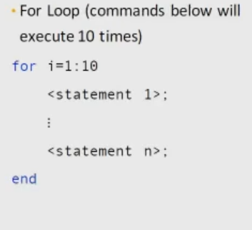

|  |  |
| --- | --- |
| Making Fibonacci series with for loop    a= [0,1]; # series initialization  n=10; #how many terms needed  for i=3:n  a(i)=a(i-1)+a(i-2); #here a(i) means in c a[i]  end  a | a =  0 1 1 2 3 5 8 13 21 34 |
| While loop |  |
| Making Fibonacci series with while loop    a= [0,1]; # series initialization  n=10; #how many terms needed  i=3  while i<=n  a(i)=a(i-1)+a(i-2); #here a(i) means in c a[i]  i++;  end  a | a =  0 1 1 2 3 5 8 13 21 34 |